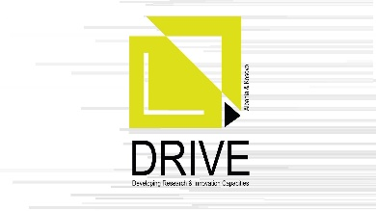
Developing Research and Innovation Capacities in Albania and Kosovo – DRIVE
The general objective of this project is to contribute in the development of the research and innovation capacities of HEIs in Albania and Kosovo by enhancing their institutional capabilities, staff skills and networking.
Specifically, the project intends to:
- Enhance the teachers’ capacities and their methodologies so that they effectively equip the students (graduate level and beyond) with the skills to conduct independent research.
- Enhance the mentors’ capacities to effectively guide the students in their research activity.
- Enhance the research capacities of the academic and managerial staff through study visits and tailored trainings.
- Strengthen the managerial capacities for research activities and innovation in institutional level by setting or strengthening dedicated research and innovation support structures (RISS).
- Promote research excellence and innovation by developing a network that eases the interdisciplinarity and cooperation among local and international actors.
These objectives have been designed to directly address the needs identified in the proposal, namely:
- The need to improve the HEIs capacities for research and innovation.
- The need to foster the links and cooperation among the actors in the innovation ecosystem.
List of partners:
1. POLIS University (Coordinator of the project)
2. European University of Tirana
3. Polytechnic University of Tirana
4. University of Prishtina “Hasan Prishtina”
5. University of Gjakova “Fehmi Agani”
6. Universum College
7. Hamburg University of Technology, Germany
8. Politecnico di Milano, Italy
9. Aalborg University, Denmark

